Multiple-choice section

|  |  |  |  |  |  |  |  |  |
| --- | --- | --- | --- | --- | --- | --- | --- | --- |
| Question | 1 | 2 | 3 | 4 | 5 | 6 | 7 | 8 |
| Answer | C | D | A | B | A | C | A | A |

Question 1 [8.1]

C

You can walk around the car park and observe the make of each car.

Question 2 [8.2]

D

1, 2, 3, 4, 6, 8

mean =  = 4

median =  = 3.5

Question 3 [8.3]

A

 = 24.5

Question 4 [8.5]

B

9 balls in total, 4 of which are brown: 

Question 5 [8.5]

A

Four 3s have been rolled out of a total of 30 rolls.



Question 6 [8.5]

C

multiples of 4: 4, 8, 12, 16, 20, 24, 28: 

Question 7 [8.7]

A

Using a tree diagram, there are 9 outcomes possible, only one where Sheldon has Korny Kobs two days in a row, so .

Question 8 [8.7]

A

Pr(*B* and even) = = = 

Multiple-choice total marks: 8

Short answer section

Question 9 3 marks [8.1, 8.4, 8.7]

(a) An event for which the probability is 1 is said to be *certain*.

(b) The number of brothers and sisters you have is an example of *discrete data*.

(c) If a statistical graph is not symmetrical it is said to be *skewed*.

Question 10 4 marks [8.6]

(Other words and phrases are possible)

10%: unlikely; 50%: even chance; 60% quite likely; 90%: most likely

Question 11 4 marks [xx]

|  |  |  |
| --- | --- | --- |
| *x* | *f* | *x* × *f* |
| 15  16  17  18  19  20 | 10  15  8  3  1  2 | 150  240  136  54  19  40 |
| Total | 39 | 639 |

mean =  ≈ 16.4

median: 19th datum = 16

range = 20 – 15 = 5

Question 12 6 marks [xx]

(a)

|  |  |  |  |
| --- | --- | --- | --- |
| Distance (m) | Frequency | Midpoint | *xf* |
| 0−<10 | 4 | 5 | 20 |
| 10−<20 | 12 | 15 | 180 |
| 20−<30 | 24 | 25 | 600 |
| 30−<40 | 9 | 35 | 315 |
| 40−<50 | 1 | 45 | 45 |
|  | Σ*f* = 50 |  | Σ*xf* = 1160 |

mean =  = 23.2

(b)

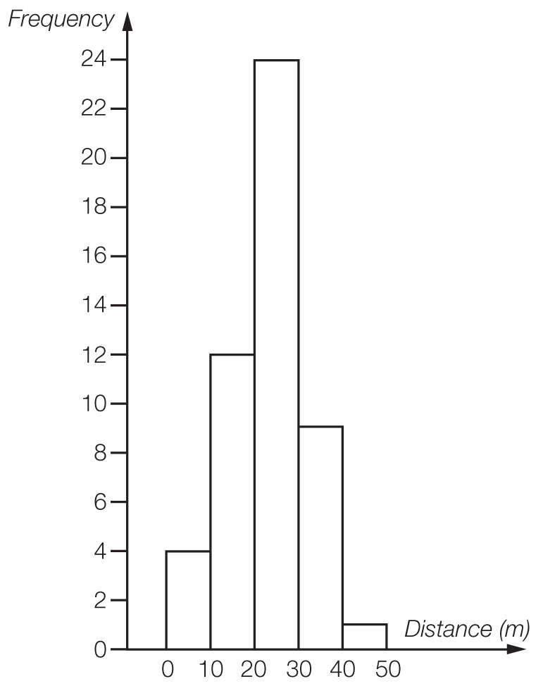

(c) The large number of values in the middle band makes this data relatively symmetrical.

Question 13 2 marks [xx]

(a) Pr(Rhonda wins) =  = 40%

(b) Pr(Michelle winning next eight games) =  × 8 = 4.8

Michelle would expect to win 5 games.

Question 14 3 marks [xx]

(a) Pr(neither red nor pink) = Pr (orange and brown) =  =  = 

(b) Pr (pink or brown)

= × 8 = 2.5

2 or 3 lollies are expected to be pink or brown.

Question 15 7 marks [8.6]

(a) (i) *A* and *B* are mutually exclusive.

(ii) *A* and *C* are not mutually exclusive.

(iii) *A* and *D* are not mutually exclusive.

(b) (i) Pr(*B* and *C*) = Pr(b, c, d, f) =  = 

(ii) Pr(*C* or *D*) =  = 

(iii) Pr(*A* and *B*) = 0 (Because a tile cannot be a vowel and consonant at the same time.)

(iv) Pr(*B* only) =  = 

(The letters that belong to set *B* only and don’t belong to the other sets i.e. set *C* or set *D*.)

Question 16 8 marks [8.7]

(a)

|  |  |  |  |  |  |  |
| --- | --- | --- | --- | --- | --- | --- |
|  | R1 | R2 | Y1 | Y2 | B1 | B2 |
| R1 |  | RR | RY | RY | RB | RB |
| R2 | RR |  | RY | RY | RB | RB |
| Y1 | YR | YR |  | YY | YB | YB |
| Y2 | YR | YR | YY |  | YB | YB |
| B1 | BR | BR | BY | BY |  | BB |
| B2 | BR | BR | BY | BY | BB |  |

(b) Pr(RR) =

(c) Pr(RR, YY or BB) = 

(d) Pr(neither blue) = 

(e) Pr(BY or YB) = 

Short answer total marks: 37

Extended answer section

Question 17 14 marks [8.4]

(a) NSW: mean = ** =** 164.2 cm

Victoria: mean =  = 167.8 cm

(b)

|  |  |  |
| --- | --- | --- |
| NSW Year 9 students |  | Victoria Year 9 students |
| 6 | 12 |  |
|  | 13 |  |
| 8 6 2 | 14 |  |
| 6 5 2 2 0 | 15 | 7 9 |
| 7 7 6 4 4 4 2 0 0 | 16 | 0 0 1 1 2 2 4 4 5 5 5 6 6 7 7 7 7 7 8 |
| 9 9 6 5 4 4 3 2 0 | 17 | 2 4 4 5 5 7 8 |
| 8 2 2 | 18 | 2 6 |

(c) NSW: median = 165 cm and range = 188 – 126 = 62 cm

Victoria: median = 166.5 cm and range = 186 – 157 = 29 cm

(d) Although the mean and median are close for the two different states the range of heights is quite different. The 9 shortest students come from NSW, as does the tallest student.

Question 18 8 marks [8.6]

(a)

|  |  |  |  |
| --- | --- | --- | --- |
|  | TV in bedroom | No TV |  |
| Ride bicycle | 2 | 8 | 10 |
| No riding | 5 | 7 | 12 |
|  | 7 | 15 | 22 |

(b)

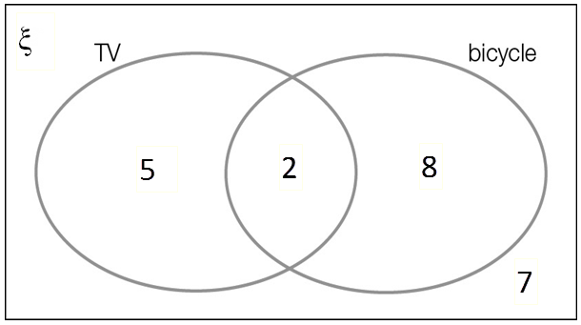

**(c)** **(i)** Pr(TV) = 

**(ii)** Pr(TV and bicycle) =  = 

**(iii)** Pr(no bicycle riding) =  = 

**(d)** Pr(TV knowing bicycle riding) =  = 

Question 19 10 marks [8.5]

**(a)** mean =  ≈ 40.0 runs

0, 0, 1, 7, 9, 12, 13, 14, 21, 21, 21 | 23, 24, 26, 37, 38, 54, 56, 65, 121, 144, 174

median = 22 runs

range = 174 – 0 = 174 runs

**(b)** **(i)** Pr(score from 0 to 9) =  × 100% ≈ 23%

**(ii)** Pr(at least 50) =  × 100% ≈ 27%

**(iii)** Pr(at least 100) =  × 100% ≈ 14%

Extended answer total marks: 32

TOTAL test marks: 77